Soul Mine Band
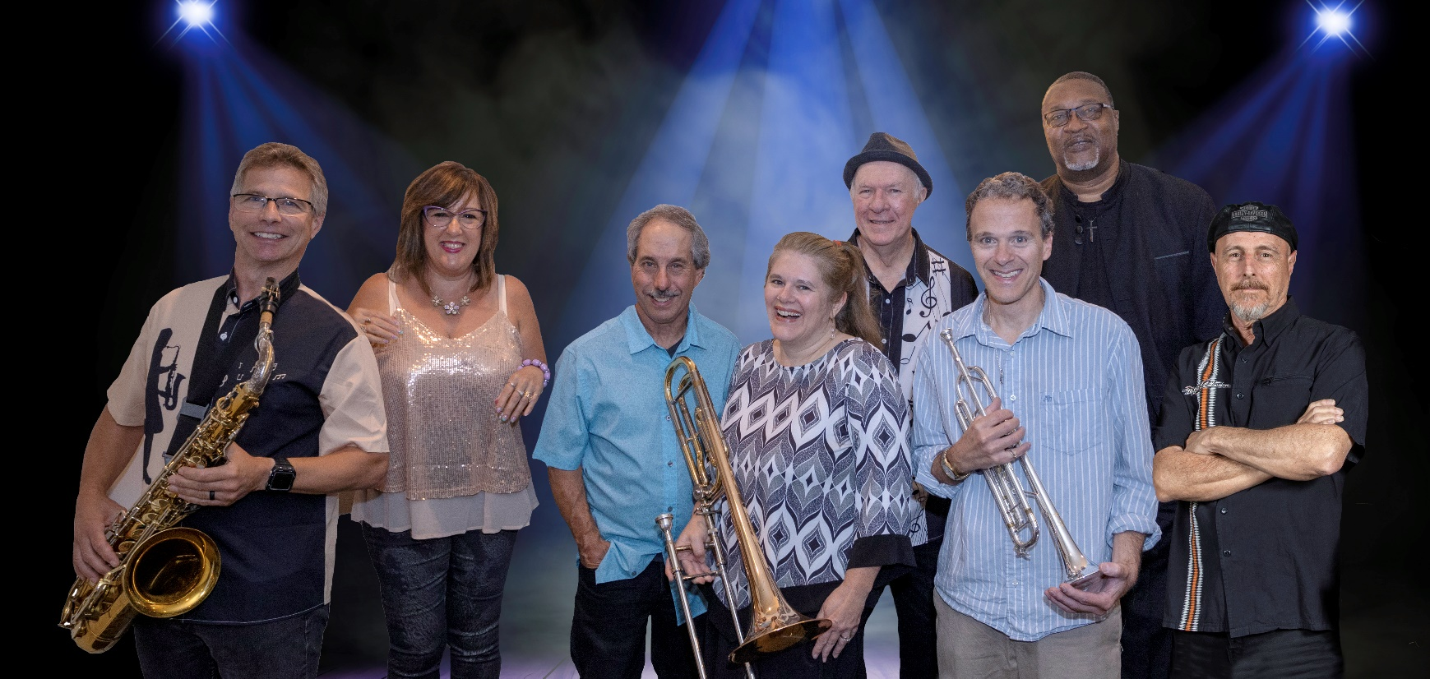
High Energy Premier Dance Party Band
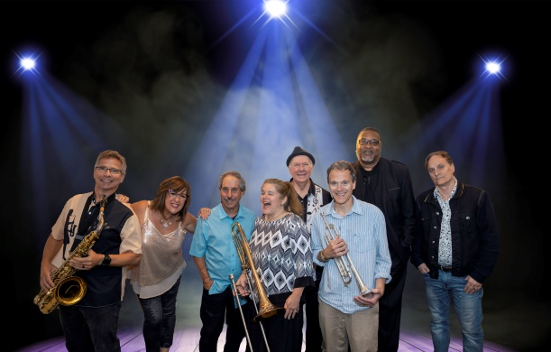
Soul Mine Members
Shelly Harris – Vocals
Jennifer Klemenz – Vocals & Trombone
Sam Sampere – Saxophone & Vocals
Jim Sorendo – Trumpet
Vynce Watson – Bass
Fred Shattell – Keyboards
Don Bullis – Guitar
Lou Micelli – Drums - Vocals
Soul Mine has performed at the Top Venues in CNY, from Casinos, to Weddings & Party’s
for more than 15 years.
Featuring Dynamic Vocals, Outstanding Horn Players, and a Driving Rhythm Section
Playing hits from the 70’s to current day
Favorites

Soul Mine www.soulmineband.net (315)263.1978

Band Bio’s

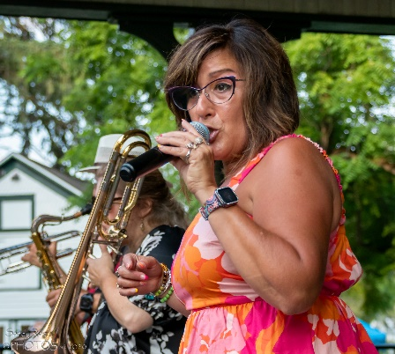

Shelly Harris Lead Vocals

Started singing at 7 years old and sang with the New Vibrations for 5 years as a teenager, have provided Lead vocals for Solar Funk Society, The Horn Dogs, and numerous duos/trios over the years. Have had the pleasure of performing for the Clintons, performed with Rock & Roll Hall of fame drummer, and opened for Smash Mouth.

Influences: are all over from Bette Midler, Fleetwood Mac, Doobie Brothers, the Beatles to Madonna, Pink, Lady Gaga and Chrissy Hyndes. Love all music and would sing anything to make our listeners happy!

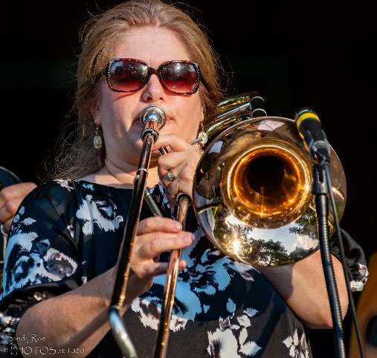
Jennifer Klemenz - Lead Vocals and Trombone
Jennifer is the latest addition to Soul Mine performing on trombone, female vocals and harmonies returning to the music scene after a several year hiatus. Jennifer is a graduate of SU School of Music where she performed with several vocal and instrumental ensembles including the SU Marching band and the renowned Windjammer vocal jazz group under the direction of notable area musicians Ronnie Leigh and Rick Montalbano.

Experience: Local CNY bands which includes Powerline, Mario DeSantis Orchestra, Terminal Velocity and The Celebration Band. Jennifer has also sung for many local wedding ceremonies as a vocal soloist, has been involved in several area churches hired on as cantor, choir director and choir participant and is a member of the Cicero-North Syracuse Alumni Marching Band.

Influences: Pat Benatar, ABBA, Basia, Ella Fitzgerald and several 80s and 90s bands.
Soul Mine www.soulmineband.net (315)263.1978

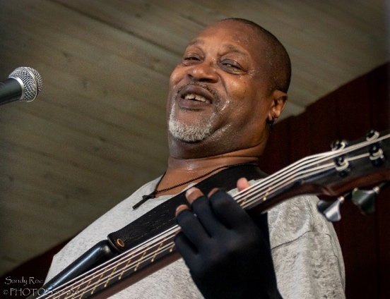

Vynce Watson Electric Bassist
Began playing Electric Bass at the age of 18 in Campbell, Ohio. Performed with notable players as Big Boogie D and the Hump Jones Trio. Did extensive travel gigging with Ex Art Blakley, sideman. saxophonist Pamon Morris. Moved to Syracuse, NY in the late 70’s and performed with the likes of Marcus Curry, Rocco Barbaro, Ronnie Lee, and Larry Arlotta. Currently performing with the Longwood Jazz Project. Bob Holtz and A Vision Forward, and the Soul Mine Band, as well as some Freelance work. Recently performed at the Syracuse National Grid Jazz Festival with the Longwood Jazz Project, and Bob Holtz

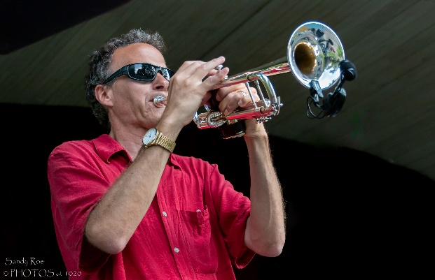

Jim Sorendo - Trumpet

Jimmy is a native of Auburn, NY and currently resides in Liverpool, NY. He began playing the trumpet in the 4th grade. He played trumpet in the Auburn High School Band Program for 4 years and also played trumpet in the Cayuga Community College Jazz Ensemble. He has played with several groups throughout the Central New York area including: The Auburn Civic Band, The Clyde Barrow Band, Private Eye, The Bizznezz, Soul Traders, Purple Lancers Drum/Bugle Corps, The Destination, Auburn School District Faculty Band, Auburn Alliance Church Orchestra, Lakes Church Worship Band, Believers Brass Quintet, Sunday Night Road Band, Bob Piorun's Music Workshop, Entourage, Joe Whiting's Sweet Soul Review, The Ron Spencer Band, Letizia and The Z Band, Tuff Luck, Soul Mine, and Soul Injection. Jimmy played trumpet at the 2018 Great Salt City Blues Concert at The Palace Theater in Syracuse and has also played at venues such as the NYS Fair and Del Lago Casino. He is employed by the Auburn Enlarged City School District as a Reading/ELA teacher.

Soul Mine www.soulmineband.net (315)263.1978

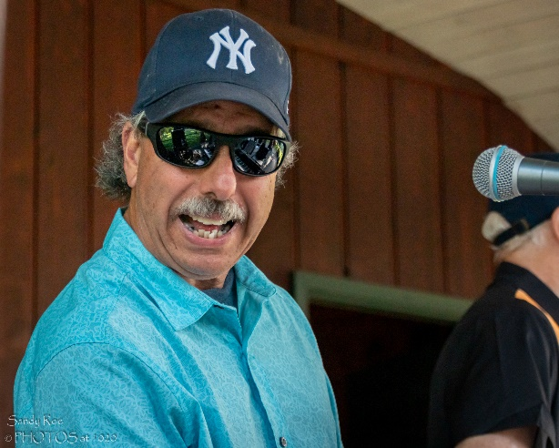
FRED SHATTELL – Keys

Fred is a seasoned veteran of the local Syracuse Music Scene, with
years’ experience as a musician and band leader. Fred’s soulful sound on the
Hammond & Roland keyboards add a warm blend of textures beneath a very funky.
Hard driving rhythm section. Currently performing with Soulmine and the Blacklites

EXPERIENCE: Private Eye, The Bizzness, Jet Lag, Fast Freight, Crimson,
The SkyLarks Big Band, The Jazz Kats
INFLUENCES: Felix Cavaliere, Jimmy Smith, Chester Thompson,
Tom Coster, and Joey DeFrancesco.

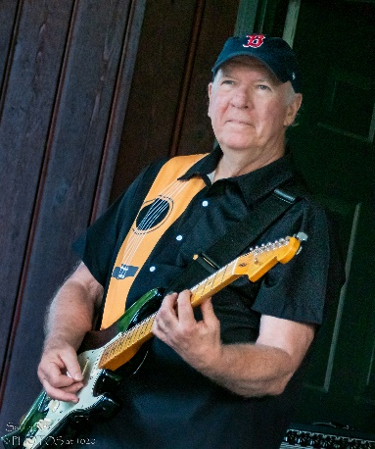
DON BULLIS -Guitar
Don is a guitarist at home in any style, He adds a funky, rockin’, bluesy edge to the Soul Mine experience.
Don is a magna cum laude graduate of Berklee College of Music. He worked for the College for several.
years before returning to Syracuse where he has been teaching and playing guitar for 30 plus years.

EXPERIENCE: Many area jazz, rock, and R&B combos including Aunt B’s Canned Music,
Steppin’ Out, Odyssey, Celebration, Cortini Brothers and Soul Mine.

INFLUENCES: Howard Roberts, John Scofield, B. B. King, and Larry Carlton.

Soul Mine www.soulmineband.net (315)263.1978

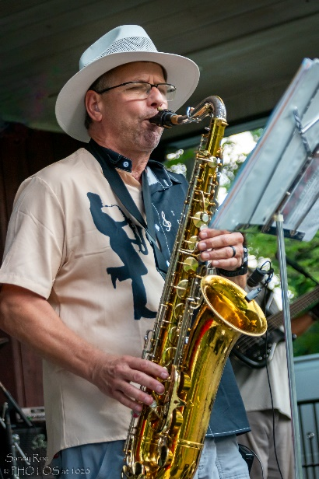
Sam Sampere – Saxophone & Vocals
Sam has been the sax player in Soul Mine for the last 5 years and brings soul and energy to the Mine. When he's not playing sax, you can find Sam teaching physics at SU or riding his bike getting ready for Ironman. Sam also plays with Utica-based Soul Injection.

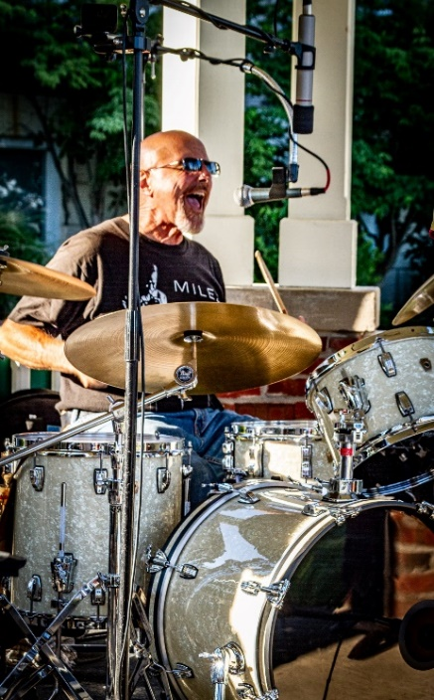
Lou Micelli Drums & Vocals
I have been playing a musical instrument starting at the age of eight years old.
My current instruments are guitar and drums.
Those interests began at the age of thirteen and have never stopped.
I have an AS degree in music from O.C.C. and have been playing professionally to this day.
Currently working with three bands Soulmine, The Strangers and Back Rhodes.
The previous bands were recording artists The Kingsnakes that won two Sammy awards.
The Celebration band that performed for wedding and corporate parties for twenty-five years.
Numerous bands throughout my musical carrier.
Soul Mine www.soulmineband.net (315)263.1978

Soul Mine www.soulmineband.net (315)263.1978

SONG LIST - ARTIST

Ain’t No Stopping Us – McFadden & Whitehead
Ain’t Too Proud To Be – The Temptations
Ain’t Nobody – Chaka Khan
Bad Girls – Donna Summer
Back In Love Again – LTD
Backstabbers – O Jays
Billy Jean – Micheal Jackson
Boogie Oogie Oogie - A Taste Of Honey
Brick House – Commadores
Cake By The Ocean - DNCE
Car Wash - Rose Royce
Can’t Stop The Feeling – Justin Timberlake
Chain of Fools - Aretha Franklin
Crazy – Scary Pockets
Dancing Queen – Abba
Diamond Studded Shoes -Yola
Dreams – Fleetwood Mac/Scary Pockets
Flowers – Myle Cyrus
Get Down Tonight - KC & The Sunshine Band
Give It To Me Baby - Rick James
Home – Michael Buble
Hollywood Swingin - Kool and the Gang
Hot Stuff - Donna Summer
Holiday - Madonna
I Can’t Get Enough Of Ur Love - Barry White
I Feel Good - James Brown
I Feel For You – Chaka Khan
I Will Survive - Gloria Gaynor
I Wish - Stevie Wonder
I’m Coming Out – Diana Ross
Into The Groove - Madonna
It’s Got To Be Real - Cheryl Lynn
Jump For My Love – Pointer Sisters
Knock On Wood – Eddie Floyd
Levitating – Dua Lipa
Late In The Evening – Paul Simon
Lady Marmalade - LaBelle
Le Freak – Chic

Listen To The Music – Doobie Bros
Long Train Running – Doobie Bros
Love Shack – B 52’s
Let’s Stay Together - Al Green
Moondance
Mustang Sally - Wilson Pickett
My Girl – Temptations
Oh What A Night – Four Seasons
Pick up the Pieces - Average White Band
Play that Funky Music - Wild Cherry
Sara Smile - Hall & Oats
Saturday In The Park – Chicago
25 or 6 To 4 - Chicago
Shake Your Groove Thing – Peaches & Herb
Shake You’re Body To The Ground – M. Jackson
Shake You’re Booty – Kc & The Sunshine Band
She Works Hard for The Money – Donna Summer
Shut Up and Dance – Walk The Moon
Sign Sealed Delivered - Stevie Wonder
September - Earth Wind & Fire
Shake Your Body - Michael Jackson
Sing A Song - Earth Wind & Fire
Sir Duke - Stevie Wonder
Superstition - Stevie Wonder
Sweet Home Chicago - Blues Brothers
Rappers Delight – The Sugar Hill Gang
Respect – Arthea Franklin
Tennessee Whiskey – Chris Stapleton
That’s The Way I Like It - KC & The Sunshine Band
Treasure - Bruno Mars
This is How We Do It - Montell Jordan
Uptown Funk -Bruno Mars
Upside Down – Diana Ross
You Can Call Me Al – Paul Simon
Walking On Sunshine – Katrina And The Waves
Walking In Rhythm – Blackbyrds
Watermelon Sugar -Harry Styles
Who Says you Can’t go Hm - J Nettles - Bon Jovi

Soul Mine www.soulmineband.net (315)263.1978

BOOKING THE BAND

Soul Mine is available to play for almost any
Venue, or Event, where Quality and Professional
Entertainment is required.
We are serious musicians and have years of experience making any
event, large or small, memorable.
If you are interested in the band, please call:
Fred Shattell (315) 263-1968

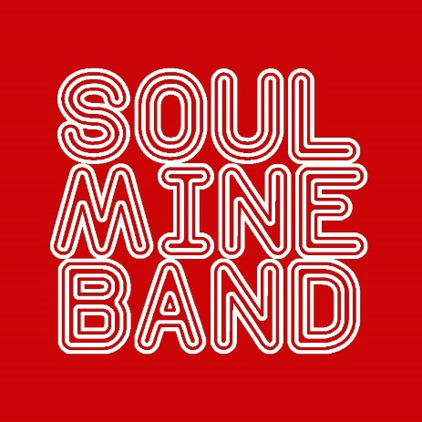

Soul Mine www.soulmineband.net (315)263.1978

